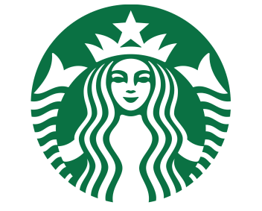 Page 1 of 2

**NEWS RELEASE**

**STARBUCKS DEVELOPING DRONE DELIVERY TECHNOLOGY**

**COFFEE DELIVERY BY DRONES SCHEDULED FOR 2015**

SEATTLE; September 23, 2014 – Starbucks Corporation (Nasdaq: SBUX) announces drone delivery testing in Seattle. Starbucks is experimenting with drone delivery technology, they have developed a miniature drone that can deliver up to four trenta (extra large) drinks in one trip. The Starbucks drone is called Dronoccino, it’s designed to keep hot drinks hot and cold drinks cold.

Starbucks drones will be able to deliver coffee in 15 minutes of ordering, in a 20-mile radius from any store. Further deliveries will take longer. Customers will be able to pay online when ordering or by using mobile payment at the time of delivery.

Depending on Federal Aviation Administration regulations you could receive coffee from Dronoccino as early as 2015. The FFA is expected to update drone regulations and laws in 2015.

“Receiving your favorite drink by drone is being held back by regulatory issues, not technical issues,” Howard Schultz, Starbucks CEO said, “when the regulations are in place Starbucks will be ready.”

Starbucks plans to continue testing until the FAA approves the commercial use of drones in the U.S. Once the regulations are in place, Starbucks will release the drone technology in test markets including rural areas outside of Seattle, Portland and San Francisco.

Starbucks plans to increase drone delivery to the entire U.S. by 2020. After the U.S. expansion, Starbucks will evaluate drone delivery in forging countries.

Drone delivery will help Starbucks deliver more cups to more people each day, allowing them to reach a segment of customers who don’t have time to visit a Starbucks location. Drone delivery will also help minimize Starbucks’ environmental footprint.

“Delivery by a Dronoccino is much greener than driving to a brick and mortar Starbucks location,” Adam Brotman Starbucks Chief Digital Officer said.

Starbucks is also investigating how drones can help them enhance their ethical sourcing of coffee.

Page 2 of 2

###

Starbucks has been committed to ethically sourcing and roasting high-quality arabica coffee since 1971. Today, with over 20,000 stores around the globe in 65 countries Starbucks continues to deliver premium coffee. Starbucks is committed to excellence and their guiding principles; this helps them bring the Starbucks Experience to life for every customer through every cup. To share in the experience, please visit us in our stores or online at [www.starbucks.com](http://www.starbucks.com/). If you have questions contact Jenny Kay Pollock, Public Relations Director at 952-913-0293 or [jkpollock@bsu.edu](mailto:jkpollock@bsu.edu).